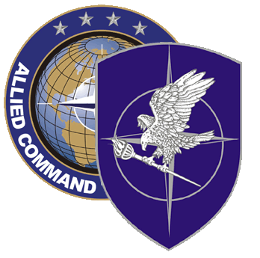
NATO SCHOOL: Global Leader in Multinational Military Education and Individual Training

M9-85 Joint Medical Planner Course

The aim of the course is to provide the necessary background knowledge to undertake a NATO medical planner’s appointment and to provide national planners with an understanding of multinational medical support planning. The main areas are: structures, doctrine and operational medical planning procedures and techniques.

Course Length: 1 week

Offerings per year: 1

Class Size: 60 max / 20 min

Security Clearance: NATO Unclassified

Rank Limitation / Characterization of Students:
Military officers, civilian equivalents and senior staff NCOs (OR- 6 to OR-9)

- Serving in or selected for assignment to a NATO HQ or agency
- Serving in a national medical staff position with involvement in NATO co-ordination.
- Others on a case-by-case and space available basis.

Prerequisites:

- Language proficiency: English IAW STANAG 6001 3232

- Computer skills: Student must be familiar with MS Word and Power Point

- Reading and Studying the read-Ahead Module by ADL.

- A sound knowledge of their national military medical structure.

- Conversant with NATO medical terms and terminology.

Course Objectives:

At course completion, the student should be able to

- Explain NATO Medical Command and Control structures.

- Identify terms specific to NATO and multinational medical support planning.

- Describe with the structure of NATO Medical Doctrine

- Describe the Operational Medical Planning Process, including:
  - Medical Estimates
  - Calculating Casualty Rates
  - Producing a Medical Plan
  - Use of Medical Intelligence
  - Major Incident Planning
  - WMD Planning

- Discuss the multinational aspects of Medical Support applications.

